**Christopher King**

**2018141521058**

**Mechanical Design 1**

**Class Section 01**

**10/06/2020**

# **Problem 1**

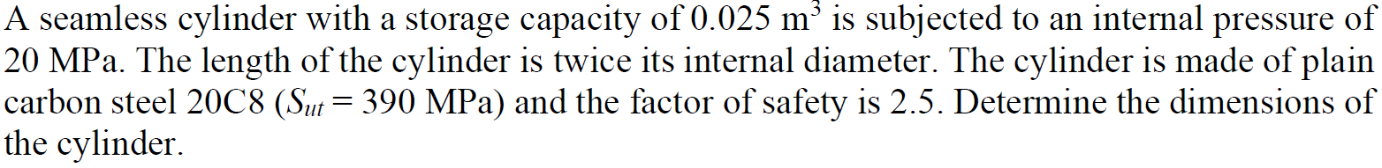

**Solution:**

For this question, we are asked to determine the dimensions of the cylinder.

Therefore, I can know that the diameter of the cylinder is equal to

And the length of the cylinder is equal to

For the limitation of the thickness,

Solving the inequation above yields that

Therefore, the dimensions of the cylinder is that

1. The diameter is .
2. The length is .
3. The thickness is .

# **Problem 2**



**Solution:**

For this question, we are asked to find the maximum tensile stress at this speed.

# **Problem 3**

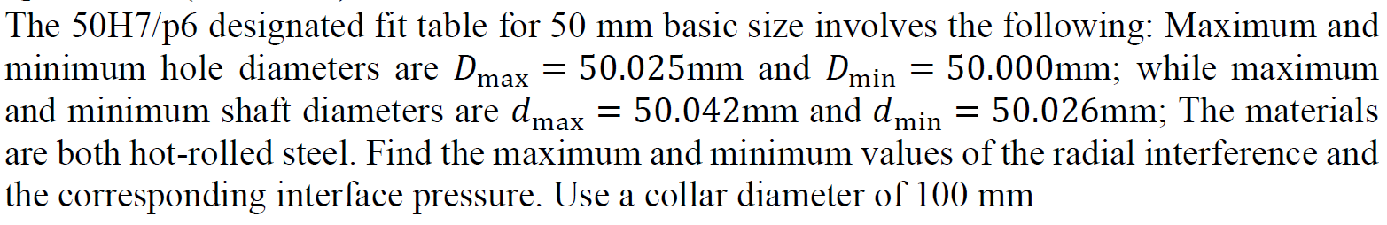

**Solution:**

For this question, we are asked to the maximum and minimum values of the radial interference and the corresponding interface pressure.

And from the question, I can know that

Therefore, I can know that

# **Problem 4**

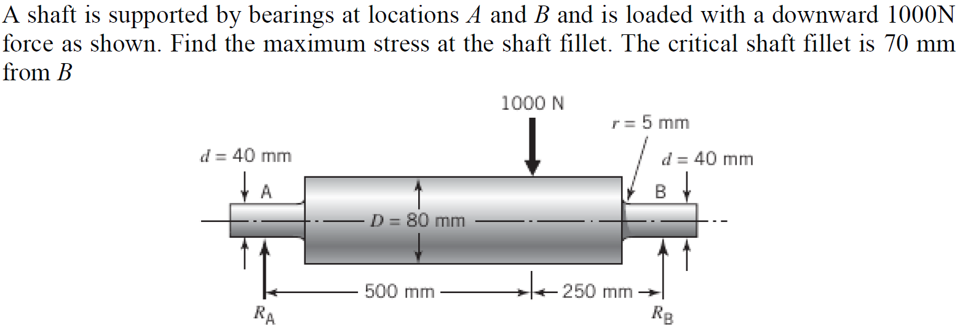

**Solution:**

For this question, we are asked to find the maximum stress at the shaft fillet.

From the graph, I can know that the stress concentration factor is equal to

Therefore, I can know that the maximum stress at the shaft fillet is equal to